Welcome!
Date
Name
Spouse
Address
City
State Zip _________
Email

Please Contact By
❑ Card  Phone  Visit

Telephone Best Time to Call
Home ______________
Work ______________

Guest: First Time Second Time
Are you a church member: yes no
Church
City, State

Circle Appropriate Age/Grade Group(s)
Preschool: Ages: B-1 2-3 4-5
Children: Grades: K 1 2 3 4 5 6
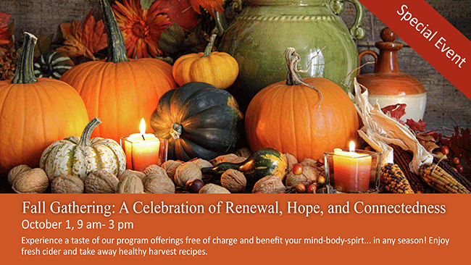
Youth: Grades: 7 8 9 10 11 12
Adults: Ages:18-29 30s 40s 50s 60s+

How did you learn about our church?
Newspaper Friend Yellow Pages Mail
Other

I am a guest of:

New in the Community? Yes No
Names & ages of children at home
Come join us for Harvest Stew! Lots of food, fun, and fellowship!! Saturday Nov 8, 2014 @ about 5:30

Weekly Service & Activity Schedule

October 26, 2014
9:45 a.m. Sunday School
11:00 a.m. Morning Worship Service
6:00 p.m. Evening Worship

Week of October 26
Wednesday, 7:00 p.m. Adult Prayer & Bible Study
Wednesday, 7:00 p.m. Youth Bible Study

Upcoming Events
November
2………..…………Operation Christmas Child Box Packing
3 – 14…………....Collecting food for Thanksgiving Baskets
8………..…………………………….…………….Harvest Stew
13…………………………………….………..Adult Fellowship
16……………………………...BGCT Annual Meeting –Waco

Church Committees for the New Year will need to meet as soon as possible, choose a committee chair, and begin planning for the upcoming year.

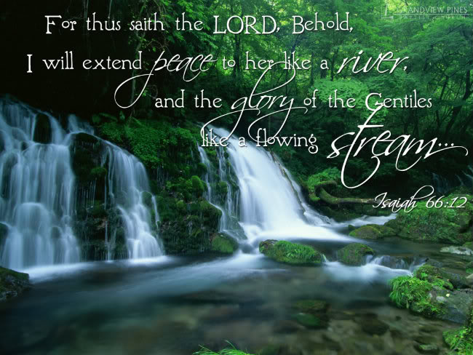

Knobbs Springs Baptist Church

Welcome Bro. James Roberts

October 26, 2014

Church Information:

KnobbsSpringsBC.com KnobbsSpringsBaptist@gmail.com
1662 CR 305, McDade, Texas 78650 512-273-2743
Patti Radford, Office Manager 512-968-7821

